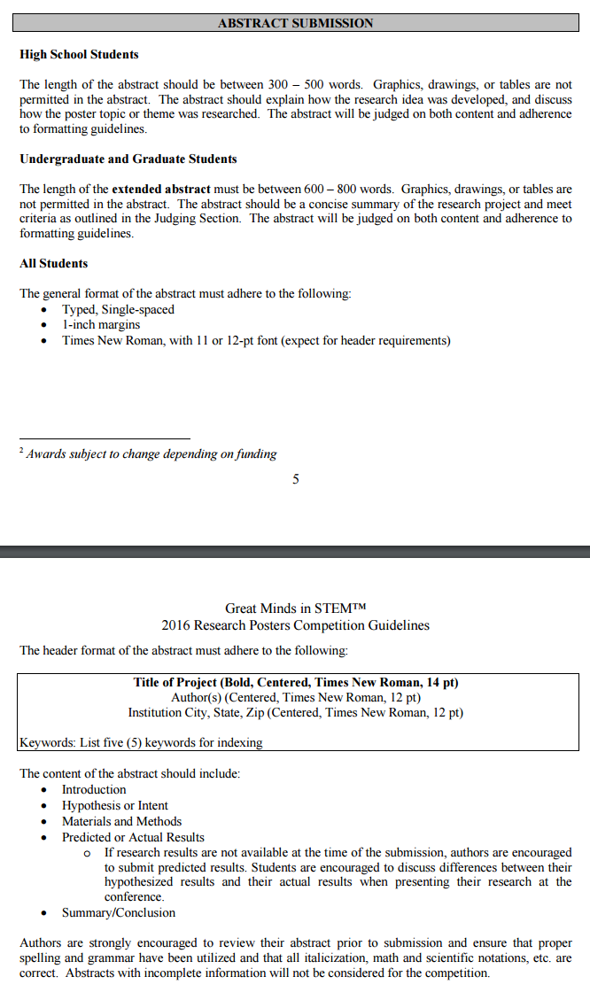 **Data Integration for Digital GeoField Mapping**

Erick Garcia1,2, Natalia Villanueva-Rosales 1,2,\*

1Department of Computer Science, 2Cyber-ShARE Center of Excellence, \*Faculty Mentor

El Paso, Texas, 79902

**Introduction**

This work is inspired in an on-going project using Augmented Reality (i.e., Digital GeoField Mapping) to enhance Geology data collection by providing additional information during the field trips. This project contributes to the challenge of integrating various disparate data sources using the vocabulary or the unifiying ontology: The *GeoField Ontology*. Although tunderstanding and retrieving these data is challenging given that it is published in different formats and it may not have enough information to reuse the data. The data sources that we are used for this project include the National Oceanic and Atmospheric Administration's National Weather Service (NOAA; <http://w1.weather.gov/xml/current_obs/>) and United States Geological Survey (USGS; [http://earthquake.usgs.gov/](http://www.google.com/url?q=http%3A%2F%2Fearthquake.usgs.gov%2F&sa=D&sntz=1&usg=AFQjCNHkPiZMXGaTGVBVNZNjqCPw02r7Qg" \t "_blank).).

**Hypothesis**

In this work we postulate that the annotation of Web data using formal vocabularies and the use of Web standards will streamline the integration of heterogeneous data on the web.

**Methodology**

The steps taken to complete the objectives of this project were the following:

1. Identifying the data sources relevant to the problem, i.e., the format of the data provided by the source and the data sharing service ;
2. Transform and annotate data with formal vocabularies (i.e., ontology terms). We used the OWL API (http://owlapi.sourceforge.net/) to create an Ontology Populator. Using the Ontology Populator we created the *GeoWeatherReport* ontology with the weather XML data. The *GeoWeatherReport* ontology can be used for several applications given the generic descriptions of its classes.As an initial step, the data of the GeoWeatherReport was integrated with the GeoFieldOntology.
3. Validate the output data with respect to consistency with formal vocabularies and data loss in the transformation process. We validated our data with respect to consistency to the GeoWeatherReport.owl and GeoFieldOntology.owl ontologies.

* (<https://docs.oracle.com/javase/tutorial/jaxp/dom/>

**Results**

Through the use of the OWL API, we created an *Ontology Populator* in the project that can be easily extended to accommodate other sources of data using Web-based standards such as XML and RDF. Using the Ontology Populator we end up with a consistent and complete *GeoWeatherReport ontology* with data from the National Oceanic and Atmospheric Administration's (NOAA) National Weather Service and the United States Geological Survey. This ontology contains all of the weather information in Weather Reports, and its contents as data properties. The integrated data was consistent with the GeoWeatherReport ontology and the GeoFieldOntology ontology. By integrating these data, we can ask questions that involve reasoning, and answer questions that involve third-party data and domain knowledge provided by Geology experts.

**Future Work**

The future work includes the integration of additional data sources to evaluate the extensibility of the developed tools and integrating input of users , initially Geology students, that can validate the integrated data as well as inference drawn using the ontologies from the domain perspective.

**Keywords:** Ontology, Web Ontology Language (OWL), Extensive Markup Language (XML), Parsing, Document Object Model (DOM)

